

Department of Electrical & Electronics Engineering

Minor Project Report on

Simulation-Guided Design of Battery Packs for Real-World Hardware Systems

By:
1. | Ashmith Shet | USN:02FE21BEE009
2. | Pooja Patil | USN:02FE22BEE022
3. | Sakshi Kadlibuddi | USN:02FE22BEE029
4. | Soujanya Bisalapur | USN:02FE22BEE042
5. Parvez Begali USN:02FE22BEE411

Semester: VI, 2025

Under the Guidance of
Prof. Tushar Birje

K.L.E SOCIETY’S
KLE Technological University, Dr. M. S. Sheshgiri Campus Belagavi -590008

2024-2025


DEPARTMENT OF ELECTRICAL & ELECTRONICS ENGINEERING
CERTIFICATE

This is to certify that project entitled “Simulation-Guided Design of Battery Packs for Real-World Hardware Systems” is a Bonafide work carried out by the student team of “Ashmith Shet
(02FE21BEE009), Pooja Patil(02FE22BEE022),Sakshi Kadlibuddi(02FE22BEE029),Soujanya Bisalapur(02FE22BEE042), Parvez Bagali(02FE22BEE411)
The project report has been approved as it satisfies the requirements with respect to the minor project work prescribed by the university curriculum for BE (VI Semester) in Department of Electrical Electronics Engineering of KLE Technological University, Dr. M. S. Sheshgiri Campus, Belagavi for the academic year 2025.

Prof. Tushar Birje | Dr. Rakhee Kallimani | Dr. S. F. Patil
Guide | Head of Department | Principal

External Viva

Name of Examiners Signature with date
1.
2.

ACKNOWLEDGMENT

We would like to express our sincere gratitude to everyone who contributed to the successful completion of this project on “Simulation-Guided Design of Battery Packs for Real-World Hardware Systems”. This endeavor would not have been possible without the valuable guidance, support, and resources provided by various individuals and organizations. First and foremost, we extend our heartfelt thanks to Prof. Tushar Birje, for their insightful advice, encouragement, and constant support throughout the project. Their expertise and constructive feedback have been instrumental in shaping this work.

Our deepest appreciation goes to our colleagues and team members for their unwavering dedication, teamwork, and innovative ideas, which greatly contributed to the successful implementation of multiple load control mechanisms. Finally, we would like to thank our families and friends for their encouragement and understanding during the course of this project. Their support has been a source of strength and motivation. Thank you all for your invaluable contributions.

-The project team

ABSTRACT

With the growing demand for sustainable energy solutions, battery storage systems have become essential in electric vehicles, renewable energy setups, and portable electronics. This project, titled "Simulation-Guided Design of Battery Packs for Real-World Hardware Systems" explores the modelling and simulation of battery packs using MATLAB Simulink. The primary objective is to understand battery behaviour under various conditions by designing a virtual model that represents real-world scenarios such as charging, discharging, thermal variations, and load changes.

The simulation approach includes creating individual cell models and integrating them into a complete battery pack. Key features analysed include voltage, current, temperature, and state of charge (SOC) during different operating cycles. Enhancements like SOC and state of health (SOH) monitoring, thermal modelling, and cell balancing strategies are implemented to improve accuracy and efficiency. The system is further supported by a hardware prototype based on the Raspberry Pi Pico, which controls relays, buzzers, LEDs, and displays status via an LCD, replicating real-time battery management logic.

Results from the simulation indicate steady SOC and voltage increase during charging and expected drops during discharging, aligning well with theoretical behaviour. The model also accurately captures effects of varying temperature and load, showing reduced efficiency under high loads and low temperatures. This integrated simulation and hardware approach demonstrates an effective and optimized method for analysing and designing battery packs, paving the way for future innovations in energy storage technologies.

Contents
- Introduction 7
  - Motivation 7
  - Objectives 7
  - Literature survey 9
  - Problem statement 10
  - Application in Societal context…………………………………………………………………...10
  - Project Planning and bill of materials 10
  - Organization of the report 11
- System design 12
  - Functional block diagram 12
  - Design alternative…………………………………………………………………………………13
  - Final design 14
- Implementation details 15
  - Specifications and final system architecture 15
  - Algorithm 18
  - Flowchart 19
- Optimization 20
  - Introduction to optimization 20
  - ypes of Optimization 20
  - Selection and justification of optimization method 21
- Results and discussions 22
  - Result Analysis 22
  - Discussion on optimization 23
  - Observations ………………………………………………………………………………………...24
- Conclusions and future scope 25
  - Conclusion 25
  - Future scope………………………………………………………………………………………25
References 26
List of Tables

- Table 1 9

- Table 2 11

List of Figures
- Block Diagram 12
- Alternative Design 13
- Final Design…………………………………………………………………………………….…..14
- Flow Chart……………….…………………………………………………………….………..….. 17
- Circuit Diagram……………………………………………………………………………………20
Chapter 1

1.Introduction

Motivation
With the growing need for clean and efficient energy, battery storage systems are widely used in electric vehicles and renewable energy setups. Designing these systems well is important for improving their performance, safety, and lifespan.
Using simulation tools like MATLAB Simulink helps us understand how battery packs behave during charging, discharging, and under different conditions—without needing physical testing. It saves time, cost, and helps in early design improvements.
This project aims to create a battery pack model using Simulink and test it with simple hardware. The goal is to study and improve the system's behaviour, making it more reliable and suitable for real-world use.

1.2 Objectives

1.To design and simulate a battery pack in Simulink.
2.To study the behavior of individual cells and their series/parallel configuration.
3.To analyze the voltage, current, and SOC characteristics during charging/discharging.
4.To integrate basic battery management logic to ensure performance and safety.
5.To evaluate efficiency and losses within the system.

1.3 Literature survey
Table 1

Title | Authors | Methodology | Results
Smart BMS with IoT-based monitoring for EV.  (2023) | Singh & Verma | An IoT-enabled BMS was implemented with cloud connectivity for remote monitoring of battery parameters. | Remote diagnostic and alerts were enabled, improving user convenience and battery safety.
Design of BMS with fault diagnosis capability for EV applications.  (2021) | Liu et al. | A BMS with diagnostic capabilities was developed using the CAN protocol and real-time fault logging. | Faults including overvoltage and short circuits were accurately detected and reported.  Faults including overvoltage and short circuits were accurately detected and reported.
A review on fire safety of Li-ion batteries.  (2020) | Wang et al. | A comprehensive literature review was conducted on thermal runaway, fire hazards and suppression methods. | Key fire risk factors  were identified with recommended preventive strategies such as venting systems.
Thermal management of Li-ion batteries for EV.  (2019) | Zhang et al | An integrated thermal model was designed and experimentally validated to optimize EV battery cooling systems. | Higher SOC accuracy was attained during varying driving cycles, enhancing performance prediction.

State of change estimation for EV batteries using Kalman filter  (2017) | Zhang et al. | An extended Kalman filter was employed to estimate the state of charge under dynamic load conditions | Higher SOC accuracy was attained during varying driving cycles, enhancing performance prediction.

1.4 Problem Statement

This project aims to model a battery pack using Simulink to study its behavior during charging, discharging, and under different conditions. A simple cell model will be created and combined to form a battery pack, helping to improve battery performance and design.

1.5 Application in Societal Context
This project supports the development of efficient battery systems for electric vehicles and renewable energy storage, promoting cleaner transportation and sustainable power use. Simulated battery models help reduce design costs and improve safety. In remote areas, reliable battery packs can provide essential electricity for homes, schools, and healthcare. Overall, the project contributes to energy efficiency, environmental protection, and better quality of life through advanced and accessible energy storage solutions.

Project Planning and bill of materials
Table 2
Component name | Specification | Cost[INR] | Quantity
Raspberry pi Pico | Microcontroller | 350 | 1
20x4 LCD display | Display | 350 | 1
Buzzer | 5V DC | 25 | 1
Flame Sensor | 3.3V or 5V | 40 | 1
Relay | 5V DC | 20x3=60 | 3
Temperature Sensor  (DHT-11) | 3.3V or 5V | 80 | 1
Resistor | 1kohm,10kohm | 10 | 10
Diode | 1N4007 | 7x2=14 | 7
Capacitor | 100uf,10uf, | 6x3=18 | 6
Switch | Push button | 5x4=20 | 4
Switch | Slide Type | 10 | 1
MOSFET | IRF540 | 80 | 2
Current Sensor | ACS712 | 120 | 1
Voltage sensor | DC 02-25V | 30 | 1
Battery | 3.7V | 50x3=150 | 3
I2C module | LCD protocol | 60 | 1
Buck Convertor | 12V,5A to 12V,2A | 75 | 1
Heat Sink | Cooling Device | 25x3=75 | 3
Screw Nuts | -- | 5x10=50 | 10
MC base | 40pins | 3 | 1
MCP3008 | De mux | 380 | 1
LED | 5mm | 2x5=10 | 5
PCB paper | 8x6 | 150 | 1
Glue stick | -- | 10x7=70 | 7
Motor | 6V | 120 | 1
Resistor | 220ohm | 20 | 4
 | Total | 2370

Organization of the report

The report starts with the Introduction and Motivation, explaining the importance of battery storage systems and the need for simulation in energy applications. It is followed by the Problem Statement and Objectives, which clearly define the goals of the project. The Methodology section outlines the modelling of the battery pack using MATLAB Simulink, including steps like cell configuration, SOC monitoring, and basic BMS logic.

The next section, Simulation and Results, presents the outcomes from charging, discharging, and different operating conditions. Hardware Implementation describes the real-world setup using Raspberry Pi Pico for control and monitoring. The report then discusses the Application in Societal Context, showing its relevance in promoting sustainable energy solutions. Finally, the Conclusion and Future Scope summarizes the project’s findings and suggests areas for future work

Chapter 2

System design

2.1 Functional block diagram

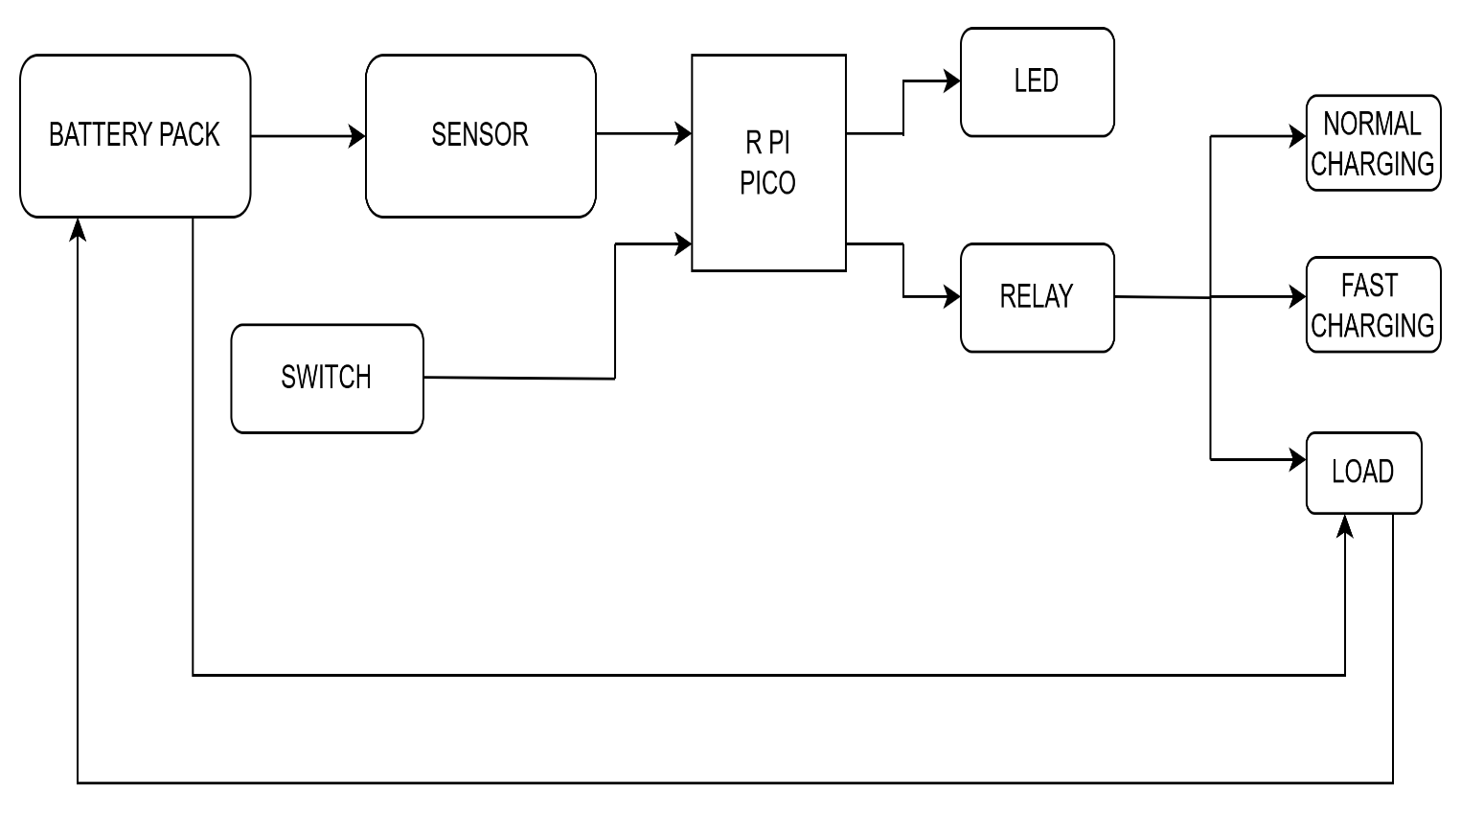

Fig 1

2.2 Design alternative

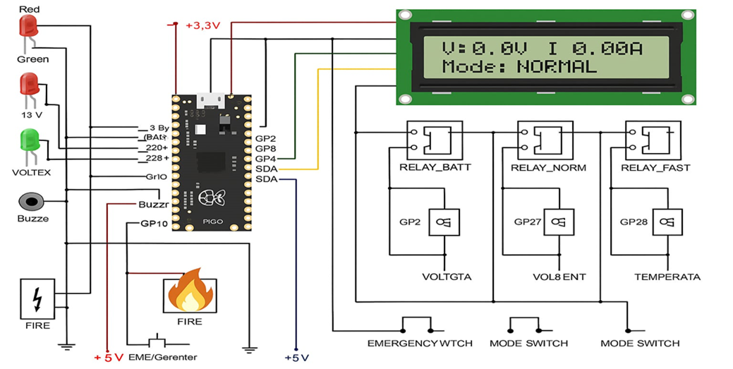

Fig 2

Final Design

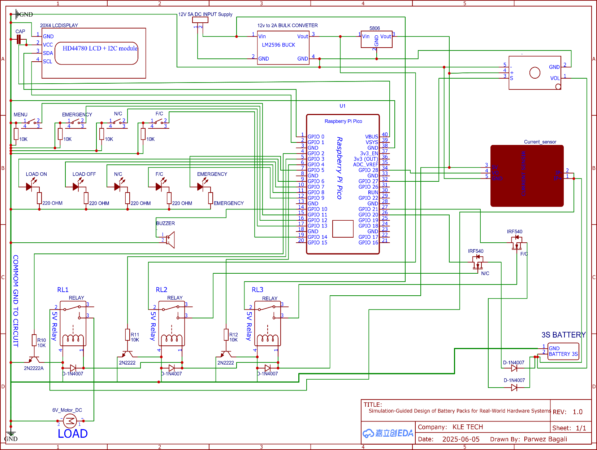

Fig 3

Chapter 3

3.Implementation details

3.1 Specifications and final system architecture
The system integrates both simulated and real-time components. In the virtual domain, the battery pack is modeled in Simulink, complete with charging/discharging control, SOC tracking, and thermal management. The simulation also includes filters and logic to emulate real-life load cycles and BMS functionality.
On the hardware side, a Raspberry Pi Pico acts as the main controller, interfacing with relays, an LCD, and indicators. It handles operational control such as switching between normal and fast charging, triggering alerts, and displaying battery status. The simulation results inform the hardware logic, ensuring that the prototype reflects real-world battery behaviors accurately.
System Architecture
The simulation models battery behavior under various conditions, while the Raspberry Pi Pico controls real-time hardware functions like relay switching, alert signals, and status display. This integration enables testing and validation of a smart, efficient battery system.
.

Algorithm

Initialize simulation parameters
- Define cell type, number of cells (series/parallel), initial SOC, and temperature.

Create battery model in Simulink
- Use equivalent circuit model.
- Add SOC, voltage, and thermal monitoring blocks.

Configure battery pack
- Connect cells in required series/parallel configuration.
- Add BMS logic for charging, discharging, and protection.

Simulate system behaviour
- Apply various charging/discharging profiles.
- Record SOC, voltage, current, and temperature responses.

Analyse results
- Identify efficiency, losses, and performance under load and thermal variations.

Design hardware control logic using Raspberry Pi Pico
- Assign GPIO pins for relays, buzzer, and LCD.
- Connect temperature and voltage sensors.

Implement hardware control
- Monitor sensor values (voltage, temperature).
- Use logic to switch relays (normal/fast charge, cutoff on fault).
- Display SOC/alerts on LCD.
- Activate buzzer or LED indicators if thresholds are crossed.

Validate simulation with hardware behaviour
- Compare real-time readings with simulation outputs

Calculation:

Battery Wh = Voltage × Current
= 11.1 × 2
= 22.2 Wh

Load Power = 6V × 2A = 12W

Time = Battery Wh / Load Power
= 22.2 Wh / 12 W
= 1.85 hours
= 1 hour 51 minutes

Charging Time:

For normal charging (12V, 2A):
Charging Time = Battery Capacity (Ah) / Charging Current (A)
= 2 Ah / 2 A
= 1 hour

For fast charging (12V, 5A):
= 2 Ah / 5 A
= 0.4 hour
= 24 minutes

Relay Coil Voltage and Current:

Voltage required = 5V
Current drawn = 40 to 100 mA

Power used by relay coil = V × I
= 5 × 0.1
= 0.5 W

Internal resistance of motor:

Power to motor
Motor resistance = 10 Ω

From V = IR,
6 / 0.6 = 10 Ω

Now at 11.1V, current would be:
I = V / R = 11.1 / 10 = 1.11 A

Power = V × I
= 11.1 V × 1.11 A = 10 W

MOSFET:
Voltage drop = 0.15 V
VDS = RDS(ON)× I
= 0.075 × 2= 0.15 V
LED (2V typical)

Voltage drop across resistor:
VR= Vinput- VLED
= 3.3 V - 2.0 V
= 1.3 V

Current through LED and resistor:
I = VR/R= 1.3 / 1000 = 0.0013 A = 1.3 mA
(Same for remaining 4 LEDs)

Buzzer:

I = V / R = 3.3 / 110 ≈ 0.03 A = 30 mA

Flowchart

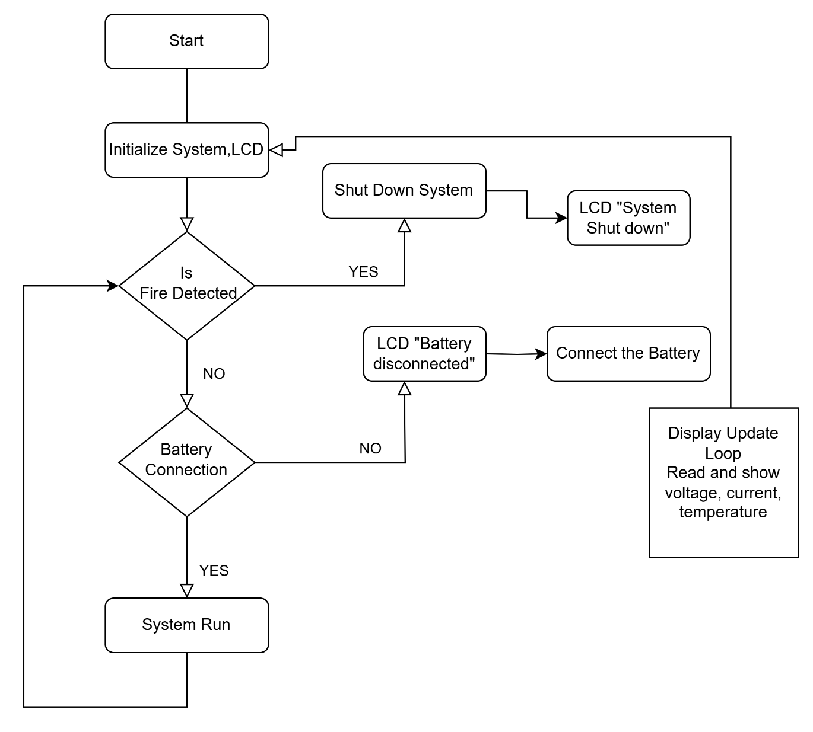

Fig 4

Chapter 4

4. Optimization

Introduction to optimization

Optimization in the context of battery system design is the process of improving system parameters to achieve the best possible performance, efficiency, and reliability. In this project, optimization is critical for enhancing the operation of battery packs in real-world scenarios such as electric vehicles and renewable energy applications. Simulation tools like MATLAB Simulink enable the testing of different design configurations and operating conditions without physical prototypes. This allows us to optimize parameters such as the number of cells, series/parallel arrangement, charging/discharging profiles, thermal limits, and state of charge (SOC) thresholds. By integrating both simulation results and hardware testing, the optimization process helps reduce energy losses, extend battery life, and improve safety. Ultimately, the goal is to achieve a balance between performance, cost, and durability, making the battery system suitable for practical and scalable use.

  - Types of Optimizations

- Parameter Optimization – Adjusting variables like number of cells, charging current, and cut-off voltage to maximize efficiency and lifespan.

- Thermal Optimization – Managing heat generation and dissipation to prevent overheating and ensure stable battery operation.

- Energy Optimization – Minimizing energy losses during charging/discharging cycles to improve overall system efficiency.

- Cost Optimization – Selecting components and configurations that balance performance with affordability.

- Control Logic Optimization – Improving the battery management system (BMS) algorithms for better fault detection, SOC estimation, and relay control.

Selection and justification of optimization method

For this project, parameter optimization using simulation-based analysis was selected. MATLAB Simulink provides a flexible platform to test various battery configurations, charging/discharging cycles, and thermal responses. This method allows us to evaluate performance metrics like SOC, voltage, and temperature under different scenarios without physical trials. It is ideal for early-stage design improvements, reduces testing costs, and helps in identifying the most efficient and safe operating conditions for real-world hardware systems.

Chapter 5

5.Results and discussions

5.1 Result Analysis
1. Charging behaviour: SOC and voltage increased steadily during the charging cycle, matching theoretical expectations.
2.Discharging behaviour: SOC and voltage dropped gradually, confirming proper load handling and energy delivery.
3.Thermal response: Efficiency decreased under high load and low-temperature conditions, highlighting the impact of thermal factors on battery performance.
4. Hardware validation: Raspberry Pi Pico accurately controlled relays, displayed SOC on the LCD, and activated alerts (buzzer/LED) based on sensor inputs.
5.Simulation-hardware correlation: Real-time hardware output closely matched simulation results, validating the design approach.
6.Optimization impact: Fine-tuning of parameters like charging thresholds and control logic improved safety, stability, and efficiency.
7.Overall performance: The integrated system showed reliable, scalable, and cost-effective behavior suitable for real-world energy applications.

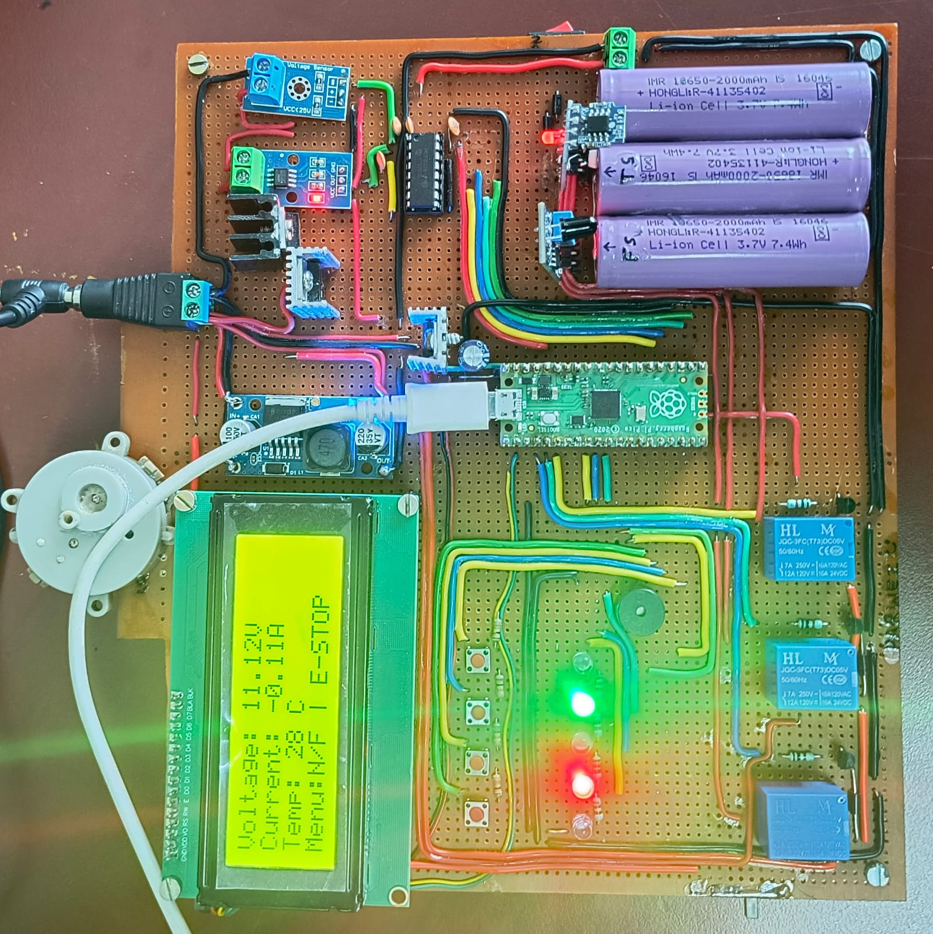

5.2 Discussion on optimization

Optimization played a key role in improving the performance and reliability of the battery system.

By adjusting parameters such as charging current, SOC limits, and relay switching logic through simulation, the system was fine-tuned for better efficiency and safety. The optimized configuration reduced energy losses and prevented issues like overcharging or overheating. Additionally, the hardware implementation benefited from this process, as the refined control logic ensured smoother operation under real-time conditions. Overall, optimization ensured that both the simulated model and the physical prototype worked effectively and consistently under various load and temperature scenarios.

5.3 Observation Table:

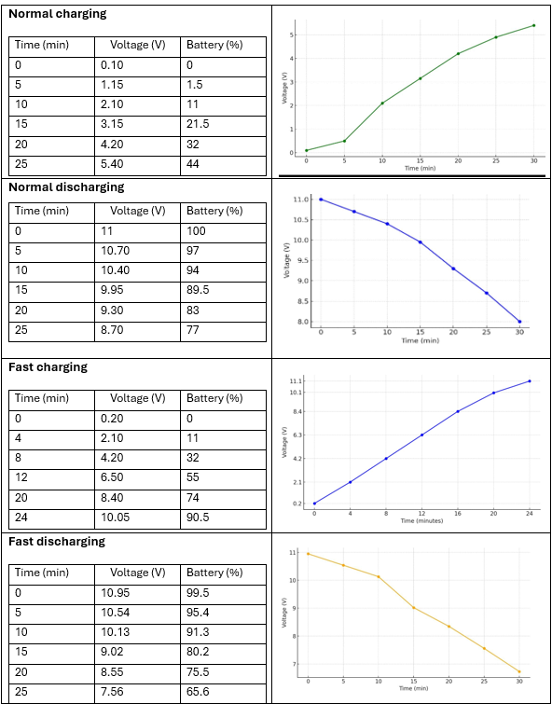
Chapter 6

Conclusions and future scope

6.1 Conclusion

This project successfully demonstrated the simulation-guided design of battery packs using MATLAB Simulink, supported by a real-time hardware prototype. The simulation model accurately represented battery behavior under various charging, discharging, and thermal conditions. Hardware implementation using Raspberry Pi Pico effectively mirrored the simulation, validating the design and control logic. Optimization techniques helped enhance system efficiency, safety, and reliability. Overall, the project provides a practical and cost-effective approach to designing smart battery systems suitable for real-world energy applications.

6.2 Future scope

1. Advanced BMS Integration: Incorporate more sophisticated battery management features like fault prediction, cell balancing, and adaptive control algorithms.

2. Improved Thermal Management: Implement active cooling techniques and advanced thermal models for better heat regulation during high-load conditions.

3. IoT and Remote Monitoring: Add wireless communication to monitor battery status remotely via mobile or web applications.

4. Machine Learning Models: Use AI/ML to predict battery health, optimize charging cycles, and extend battery life based on usage patterns.

5. Scalability to Larger Systems: Expand the simulation and hardware logic to support higher-capacity battery packs used in electric vehicles or grid storage.

6. Renewable Integration: Adapt the system for solar or wind energy storage applications, making it suitable for off-grid and sustainable setups.

References

- K. Kim, H. Lee, and J. Park, "Thermal Management of Li-ion Batteries for Electric Vehicles," Journal of Power Sources, vol. 412, pp. 548–560, 2019.
- Y. Zhang, C. Li, and M. Wang, "State of Charge Estimation for EV Batteries Using Kalman
Filter," IEEE Transactions on Industrial Electronics, vol. 64, no. 2, pp. 1280–1290, Feb. 2017.

- J. Wang, L. Liu, and X. Zhao, "A Review on Fire Safety of Lithium-ion Batteries," Energy Reports, vol. 6, pp. 437–447, 2020.
- H. Liu, S. Chen, and Y. Xu, "Design of BMS with Fault Diagnosis Capability for EV Applications," IEEE Access, vol. 9, pp. 89432–89445, 2021.
- R. Singh and A. Verma, "Smart BMS with IoT-Based Monitoring for Electric Vehicles," International Journal of Energy Research, vol. 47, no. 2, pp. 1891–1902, 2023.
- Chen et al. (2022) – Used Model Predictive Control (MPC) for battery pack balancing in EVs, improving SOC uniformity and efficiency.
- Gupta & Rao (2021) – Combined Simulink and FPGA for real-time BMS testing using Hardware-in-the-Loop, enhancing safety and accuracy.
- Sharma et al. (2023) – Applied AI (ANN & SVM) for SOC estimation, achieving better accuracy than traditional methods.
- Patel & Desai (2020) – Developed an IoT-based battery monitoring system for smart grids, enabling remote alerts and real-time tracking.
- Banerjee et al. (2024) – Simulated thermal behavior of battery packs in Simulink, optimizing cooling and reducing thermal hotspots by 30%

